**KHALSA COLLEGE OF ENGINEERING & TECHNOLOGY**



(Affiliated BY NAAC)

**Industrial Training Report on**

**Front- End Web Development**

Bachelor of Technology

Computer Science & Engineering

BY

SANJANA KUMARI (2304154)

Department of B. Tech CSE 5th Sem

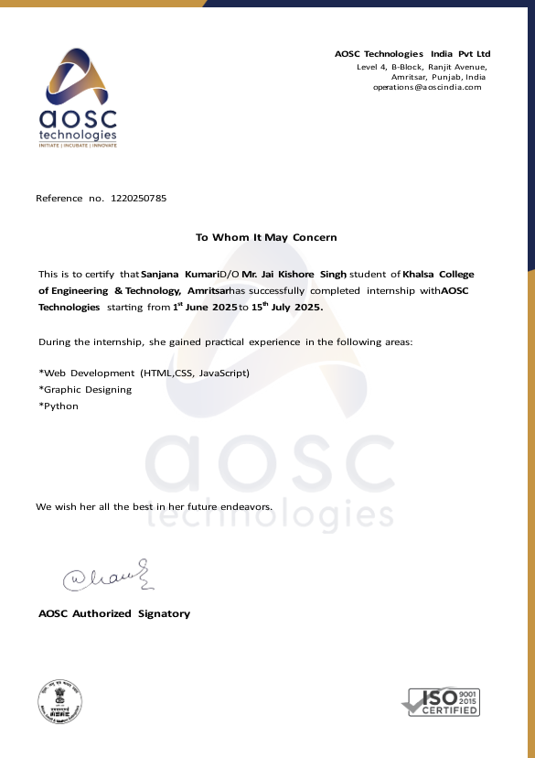

**INDEX**

|  |  |  |
| --- | --- | --- |
| **S.No.** | **TABLE OF CONTENT** | **PAGE** |
| 1. | INTRODUCTION | 4-4 |
| 2. | OBJECTIVE | 5-7 |
| 3. | FUTURE SCOPE & BENEFITS | 8-9 |
| 4. | REQUIREMENT ANALYSIS AND SPECIFICATION | 10-11 |
| 5. | TECHNOLOGY USED | 12-13 |
| 6. | DATA FLOW DIAGRAM | 14-14 |
| 7. | IMPLEMENTATION AND SCREENSHOTS | 15-18 |
| 8. | CONCLUSION | 19-19 |

**1. INTRODUCTION**

This project involves the development of a comprehensive e-commerce web application that serves as a premium, visually captivating platform for showcasing and selling exquisite jewellery collections. The application is specifically designed to organize and display a diverse range of products, including gold ornaments, diamond collections, luxury watches, and gemstone-encrusted accessories.

At the heart of the application is an elegant and dynamic landing page that combines high-end aesthetic design with intuitive user navigation. This landing page acts as a sophisticated gateway to multiple dedicated , each tailored to highlight different categories of the jewellery business and enhance the customer’s shopping journey. These sections include:

* New Arrivals: A curated showcase of the latest trends and seasonal jewelry pieces that reflect current market styles and craftsmanship.
* Product Collections: Vibrant galleries categorized by metal type (Gold, Silver, Platinum) and occasion (Bridal, Casual, Formal), capturing the essence of luxury and exploration.
* Customer Testimonials: A space dedicated to documenting client experiences and building brand trust through shared reviews and success stories.
* Detailed Specifications: A section providing context and additional information about metal purity (Karat), gemstone weight (Carat), and hallmarking details, enhancing the narrative behind each piece shared.

he ultimate goal of this web application is to create a unique and memorable online presence that effectively communicates the brand's story through a compelling blend of visuals and design. By organizing and sharing these meaningful and precious collections, the project aims to resonate with customers, evoke emotions .

**2. OBJECTIVE**

The primary objective of this project is to conceptualize, design, and develop a comprehensive e-commerce web application that functions as a high-end digital showroom for exquisite jewellery. This platform is intended to showcase the elegance of fine ornaments, highlighting the brand's commitment to craftsmanship, quality, and luxury

**Provide an Organized and Accessible Digital Showroom**

One of the key goals of this project is to create a structured and user-friendly interface for presenting various categories of jewellery, such as rings, necklaces, and luxury watches. The application is designed to:

* **Offer a Centralized Repository:** Organize and display high-definition photo galleries of jewellery, ensuring that visitors can browse through intricate collections with ease and clarity.
* **Feature Curated Collections:** Categorize content into distinct themes, such as "Bridal Wear," "Daily Elegance," and "Men’s Luxury Accessories," allowing users to find pieces tailored to specific occasions.
* **Employ Intuitive Navigation:** Use a seamless filtering and search system (based on price, metal purity, and gemstone type) that allows users to gain deeper insights into the technical specifications of each piece.
* **Contextual Storytelling:** Incorporate descriptive narratives and "Price Breakups" (gold rate, labor charges, stone value) to provide transparency and enhance the emotional connection between the jewelry and the buyer.

**Ensure Compatibility Through Responsive Design**

A critical component of the jewellery project is the implementation of responsive design to ensure that the "brilliance" of the products is accessible on any device. Key considerations include:

* **Fluid Layout Adaptability:** Developing a design that adapts effortlessly to various screen sizes, providing a seamless viewing experience across desktops, tablets, and smartphones.
* **Dynamic Asset Management:** Ensuring that high-resolution jewellery images and 360-degree product views reflow dynamically without compromising site speed or visual quality.
* **Optimization via Frameworks:** Leveraging CSS media queries and modern frameworks (like Bootstrap or Tailwind) to optimize the user interface for both portrait and landscape orientations, ensuring the shopping cart remains functional at all times.
* **Accessibility for All:** Prioritizing features such as scalable text and high-contrast colour schemes to cater to a diverse range of users while maintaining a premium brand identity.

**Demonstrate Technical Proficiency in E-commerce Development**

This project serves as a hands-on demonstration of the creator’s expertise in modern full-stack web development. The following technical objectives are emphasized:

* **Core Technology Utilization:** Using HTML5, CSS3, and JavaScript to construct a well-structured, interactive application featuring image-zoom and hover effects essential for jewellery inspection.
* **Secure System Integration:** Integrating modern payment gateways (e.g., Stripe) and SSL encryption to ensure that high-value transactions are handled with the highest level of security.
* **Back-End Logic:** Writing clean and efficient code to manage a centralized database for inventory, user profiles, and order tracking, ensuring the system is scalable for future business growth.

**Showcase Branding and Creative Design**

* The application also acts as a creative portfolio that reflects the developer’s ability to build a "luxury brand" through code. Specific elements include:
* Sophisticated Design Choices: The selection of "Gold" and "Platinum" colour palettes, premium typography, and minimalist layouts that contribute to a cohesive and striking brand presentation.
* Engagement Features: Incorporation of interactive features like virtual try-on concepts or detailed certificate pop-ups that engage users and build trust in the product's authenticity.
* Aesthetic Balance: Paying close attention to the harmony between technical "Form" (functionality) and artistic "Function" (beauty), ensuring that the technology never distracts from the jewelry itself
* informace Optimization: Solving real-world challenges such as image compression (to maintain high-quality visuals without lag) and cross-browser compatibility.

**Conclusion of Objectives**

By achieving these objectives, this jewellery website project aspires to:

* Establish a lasting impression of Trust and Luxury, effectively
* communicating the brand's vision and the artistry of its collections.
* Act as a Professional Milestone for the developer, proving proficiency in building complex, high-value e-commerce systems.
* Provide a Scalable Foundation for future enhancements, such as AI-based size recommendations or Blockchain-based diamond tracking.

**3. FUTURE SCOPE & BENEFITS**

**1. FUTURE SCOPE**

The jewellery project has significant potential for technical and functional growth, ensuring it remains competitive in the evolving digital luxury market.

**Virtual Try-On & Augmented Reality (AR)**

* **Feature:** Implement AR technology to allow customers to virtually "wear" rings, earrings, or necklaces using their smartphone camera.
* **Impact:** Reduces the "uncertainty gap" in online jewellery shopping and significantly lowers product return rates.

**Dynamic Pricing & Live Metal Rates**

* **Feature:** Integrate APIs that fetch real-time market prices for Gold, Silver, and Platinum.
* **Impact:** Automatically adjusts product pricing based on daily market fluctuations and the specific weight of the jewellery piece.

**3D Product Configurator**

* **Feature:** Develop an interactive 3D tool where users can customize their jewellery (e.g., changing the diamond cut, choosing between 14k/18k gold, or adding custom engravings).
* **Impact:** Provides a bespoke shopping experience, catering to the high demand for personalized luxury items.

**Blockchain for Authenticity**

* **Feature:** Use blockchain technology to provide digital "Certificates of Authenticity" or NFTs for high-value gemstones and hallmarked gold.
* **Impact:** Enhances customer trust by providing a tamper-proof record of the jewelry's origin, purity, and ownership.

**Advanced Visual Storytelling**

* **Feature:** Incorporate **GSAP** for smooth scroll-triggered animations that showcase the "making-of" process (from sketch to final polish).
* **Impact:** Elevates the brand’s luxury feel through high-end cinematic transitions and 360-degree interactive product views.

**2. BENEFITS**

Beyond a simple website, this project serves as a strategic asset for business scaling and professional credibility.

**Enhanced Brand Trust & Prestige**

* **Detail:** A high-quality digital jewelry platform acts as a virtual flagship store. It establishes a "luxury-first" impression that is vital for selling high-ticket items.
* **Benefit:** Builds immediate credibility with affluent clients who expect a seamless, secure, and aesthetic browsing experience.

**Global Reach & 24/7 Showroom**

* **Detail:** Unlike a physical jewelry boutique, the website is accessible worldwide at any time.
* **Benefit:** Breaks geographical barriers, allowing a local artisan or brand to capture international markets without the overhead of physical branches.

**4. REQUIREMENT ANALYSIS AND SPECIFICATION**

A thorough analysis of the project requirements is crucial to ensure clarity in both functionality and performance expectations. For a luxury e-commerce platform, these requirements must balance high-end visual aesthetics with secure, high-performance backend logic. These requirements are divided into **Functional** and **Non-Functional** categories.

**Functional Requirements**

1. **Premium Navigation Bar**

* **Implementation:** A fully functional, "sticky" navigation bar must be implemented to ensure that users can access categories at any point while scrolling.
* **Content:** The bar should include links to essential sections: *Home, Shop by Category (Rings, Necklaces, Bracelets), New Arrivals, Gift Guide, Shopping Cart,* and *User Profile.*
* **Usability:** It must feature a "Mega Menu" style for jewellery categories and include visual cues like gold-tinted hover effects to guide users through the luxury collections.

**2. Product and Dynamic Galleries**

* **Organization:** Dedicated sections must be created for different jewellery types (Gold, Diamond, Platinum) to ensure organized content presentation and ease of discovery.
* **Design:** Each product must have a high-resolution gallery. The implementation should include a **Loupe (Zoom) feature** so users can inspect the clarity of diamonds and the detail of the metalwork.
* **Features:** Users should be able to view images in a 360-degree carousel format to simulate the experience of viewing a piece of jewellery in a physical store.

**3. Interactive Inquiry and Booking Form**

* **Functionality:** A "Book an Appointment" or "Customization Inquiry" form should be included, allowing visitors to request bespoke jewellery designs or store visits.
* **Data Collection:** The form must collect essential information: *Name, Contact Number, Metal Preference (18k/22k),* and *Budget Range.*
* **Validation:** Strict validation must ensure that contact numbers are correct and that users provide all necessary details before the request is sent to the admin.

**4. E-commerce Checkout & Responsive Design**

* **Adaptability:** The website must be designed to adapt seamlessly to a variety of devices. Jewellery shopping often happens on mobile devices; therefore, the mobile UI must be as elegant as the desktop version.
* **Dynamic Elements:** The shopping cart and payment icons should resize dynamically, ensuring that the "Buy Now" button is always easily accessible without cluttering the screen.

**Non-Functional Requirements**

**1. Performance and Speed**

* **Loading Time:** Because jewellery websites use many high-resolution images, the site must be optimized to load within **3 seconds**.
* **Optimization:** Techniques such as **Lazy Loading** for images and minification of CSS/JavaScript files must be employed to prevent high-quality assets from slowing down the user experience.

**2. Adherence to Security & Modern Standards**

* **Security (SSL):** Since this project involves high-value items, the website must use HTTPS and SSL certification to protect user data and financial transactions.
* **Accessibility:** The website should follow WCAG guidelines, ensuring that font sizes are readable and that the luxury colour palette maintains proper contrast ratios for users with visual impairments.

**Conclusion**

By adhering to these comprehensive functional and non-functional requirements, the jewellery project aims to deliver a robust, user-friendly, and high-performing web application. This approach ensures the platform meets modern e-commerce standards while exceeding the expectations of a premium clientele.

**5. TECHNOLOGY USED**

The jewellery website project leverages a sophisticated combination of modern web development technologies to deliver a visually opulent, responsive, and secure shopping experience. Each technology plays a vital role in creating a robust application capable of handling high-value digital assets and complex user interactions.

**HTML (Hypertext Markup Language)**

HTML forms the structural foundation of the project by defining the semantic content and organization of the jewellery storefront. It is used to:

* **Create Semantic Sections:** Define structured areas for product titles, purity specifications, and luxury categories such as Rings, Necklaces, and Bracelets.
* **Design High-Definition Galleries:** Establish a framework for high-resolution image containers that allow customers to view the fine details of gemstones and metalwork.
* **Incorporate Metadata:** Utilize semantic tags for better accessibility and SEO optimization, ensuring the brand appears in searches for "Luxury Jewellery" or "Fine Gol."

**CSS (Cascading Style Sheets)**

CSS is employed to style the web pages, ensuring the digital showroom reflects the prestige of a physical jewellery boutique. It focuses on:

* **Layout Adjustments:** Designing a responsive and fluid layout that maintains the "brilliance" of product photos across all screen sizes.
* **Luxury Colour Schemes:** Implementing consistent palettes—such as **Champagne Gold (#D4AF37)**, Royal Silver, and Deep Charcoal—to reflect the project’s high-end theme.
* **Typography and Spacing:** Ensuring readability of technical specs (like Karat and Carat) through elegant serif font choices and balanced white space.
* **Interactive Animations:** Adding subtle transitions and hover effects to product cards to simulate the "sparkle" of jewelry when a user interacts with an item.

**JavaScript**

JavaScript introduces dynamic functionality and real-time interactivity, which are essential for a modern e-commerce user experience. Key uses include:

* **Image Magnification:** Enabling a "Zoom-in" or "Loupe" feature so users can inspect hallmark stamps and diamond clarity without reloading the page.
* **Dynamic Content Updates:** Allowing the shopping cart and price totals to update instantly as users add or remove items.
* **Event Handling:** Managing critical user interactions such as "Add to Cart" clicks, form submissions for customization, and category filtering logic.
* **Smooth Scrolling:** Enabling seamless navigation between the hero banner and featured collections for a polished, high-end feel.

**Bootstrap**

Bootstrap, a popular front-end framework, simplifies the development process and ensures the site is mobile-ready—a critical requirement for modern luxury shoppers.

* **Responsive Grid System:** Provides a flexible structure to ensure jewelry grids (e.g., a 3-column layout for rings) align perfectly on desktops, tablets, and smartphones.
* **Pre-designed Components:** Speeds up development by offering ready-to-use elements like "Sticky" navigation bars, elegant modals for product previews, and carousels for the home page banner.
* **Custom Styling:** Allows for easy customization of components to align with the unique visual identity and branding of the jewellery project.

**Other Potential Tools and Libraries**

While not explicitly implemented in the current version, the following tools may be integrated in future iterations to enhance the application:

* **Font Awesome:** For incorporating scalable icons representing the shopping cart, user account, and social media handles.
* **SASS/LESS:** For advanced CSS preprocessing to manage complex style sheets for a large-scale jewellery .
* **jQuery:** For simplified DOM manipulation to handle complex animations or legacy browser support.

**6. DATA FLOW DIAGRAM (DFD)**

**Concept and Significance**

A Data Flow Diagram (DFD) is a traditional visual representation of the information flows within a system. A neat and clear DFD can graphically depict the precise scope and requirements of a system.

For the **Jewellery E-commerce System**, the DFD serves as a foundational blueprint for developers, mapping out the entire data life cycle—from the moment a customer browses a product to the generation of a final invoice.

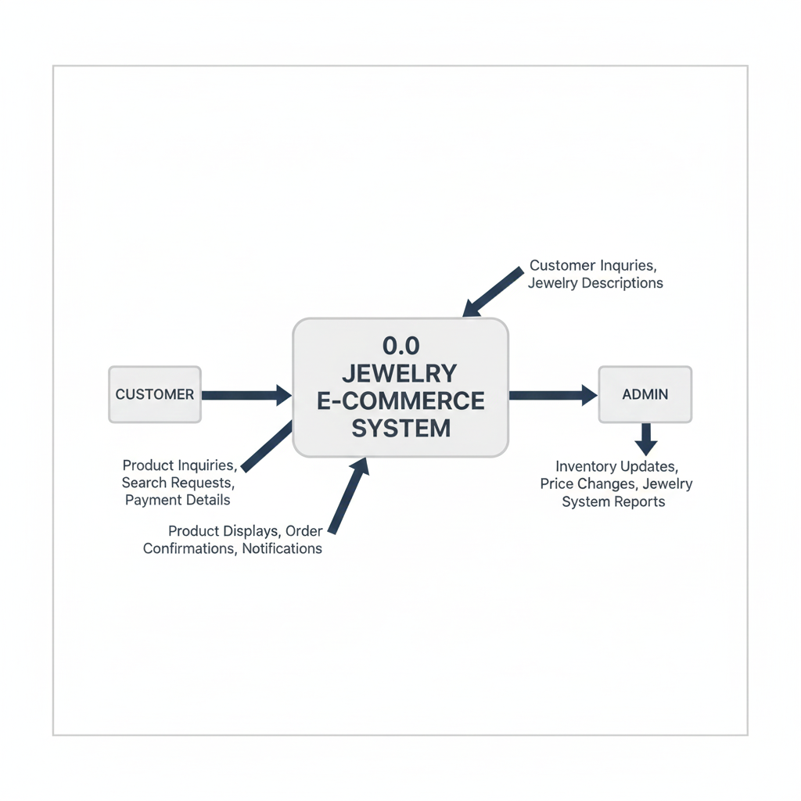

**Detailed Process Flow**

The Level 1 DFD breaks down the main process (0.0 Jewelry E-commerce System) into its core sub-processes. This provides a more granular view of how data is processed, stored, and moved within the system for key functionalities such as product browsing, order processing, and customer management.

**7. IMPLEMENTATION AND SCREENSHOTS**

* The project’s folder structure includes HTML files, CSS stylesheets, and JavaScript files.

External libraries such as Bootstrap

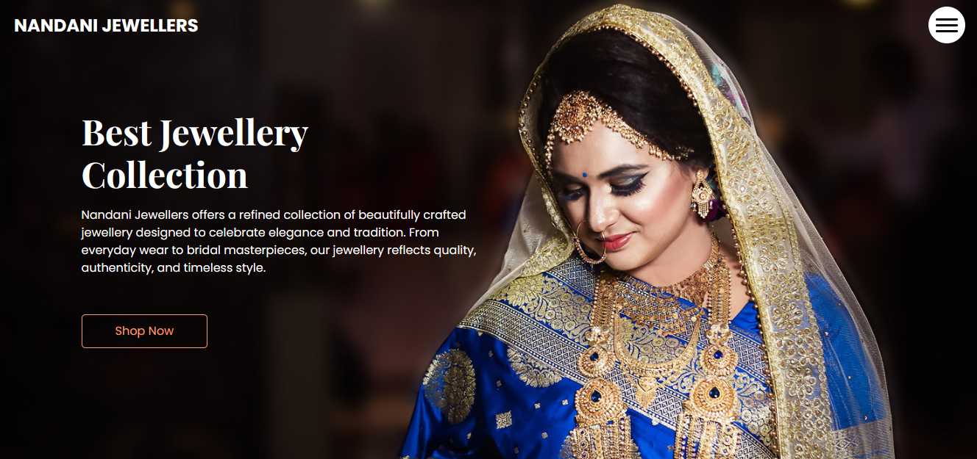

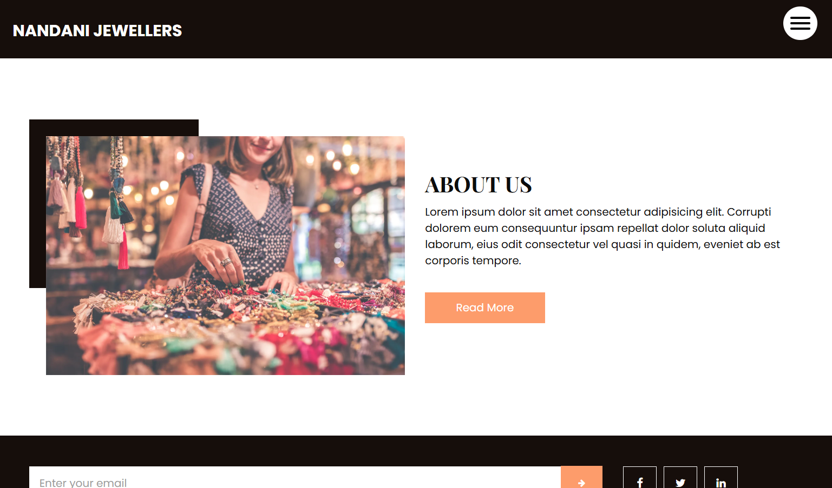

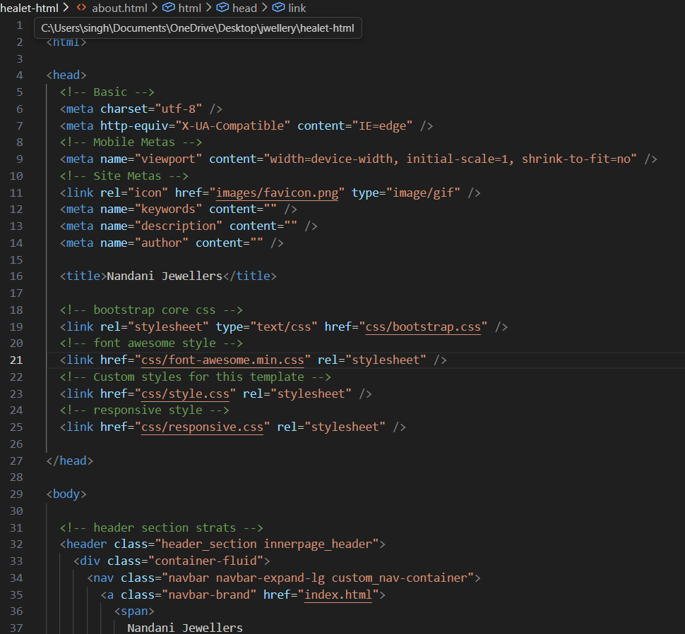

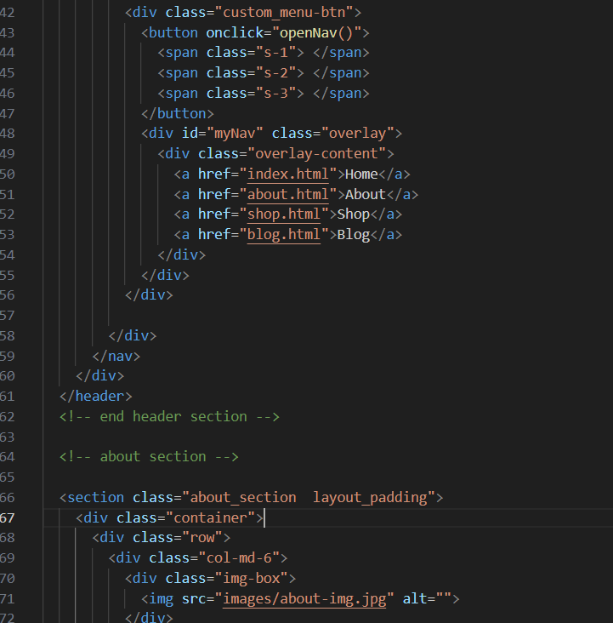

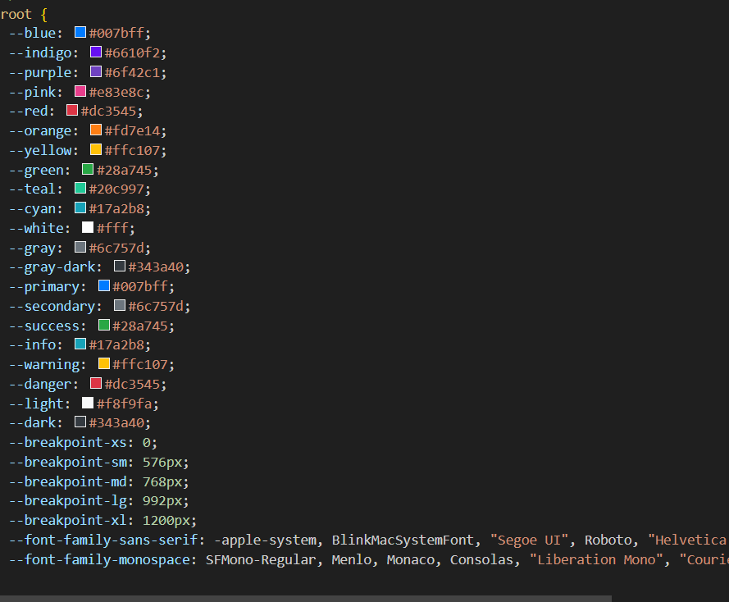

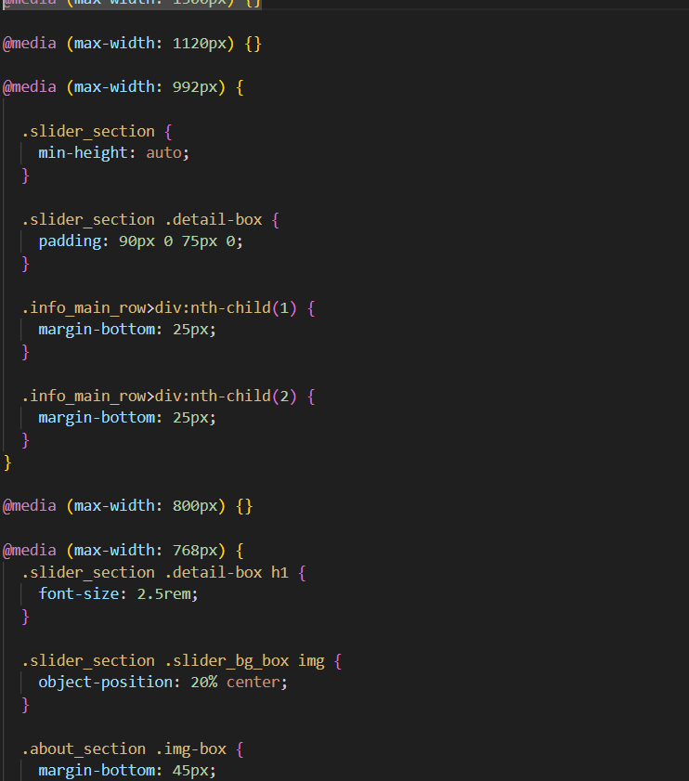

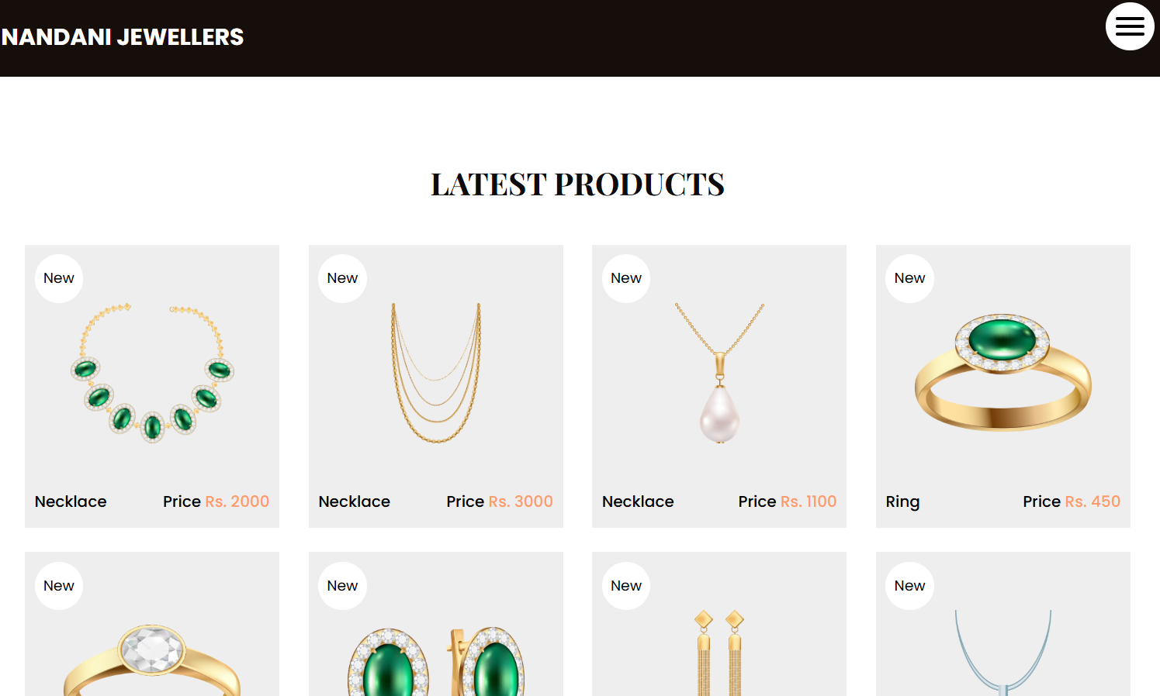

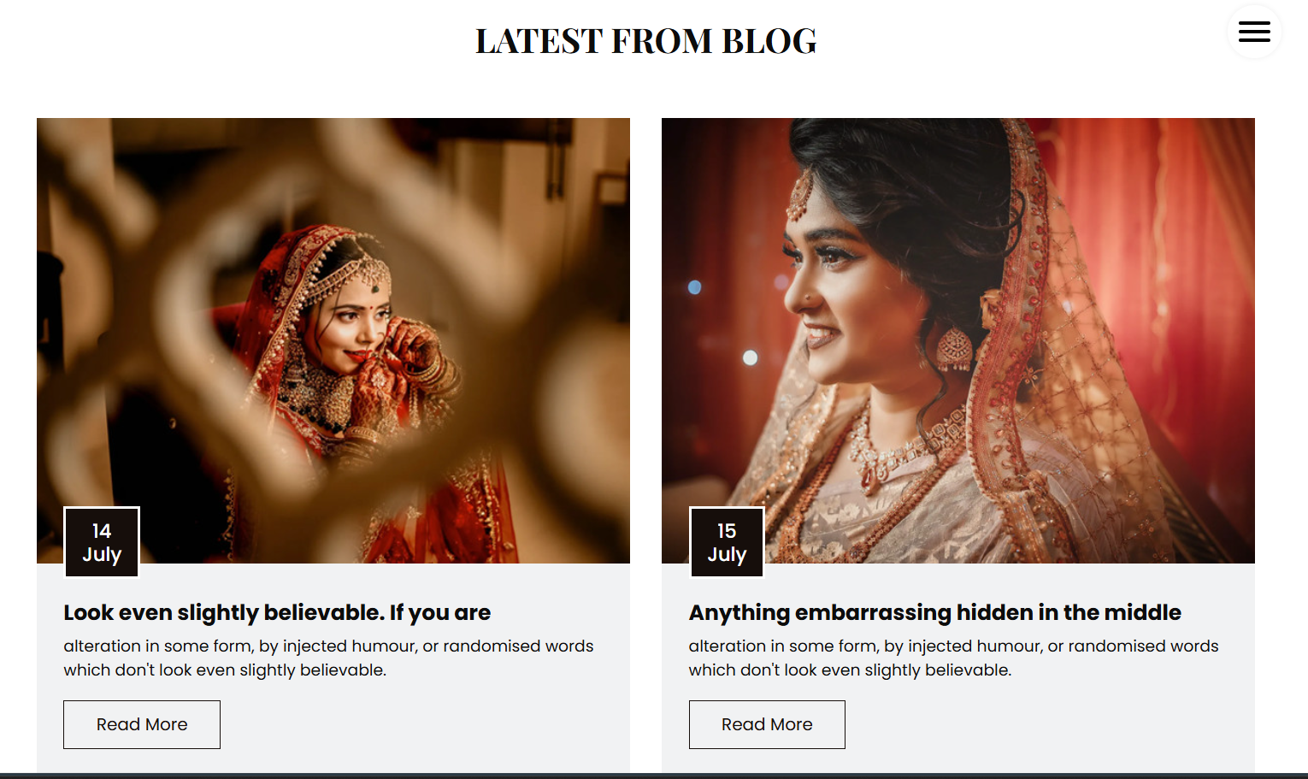

**8. CONCLUSION**

This project exemplifies the strategic application of modern front-end technologies to design and develop a luxurious, responsive, and high-performance e-commerce platform for jewelry. By successfully blending high-quality visual storytelling with a seamless shopping experience, the platform serves as both a sophisticated digital storefront and a testament to the creator's ability to build industry-specific web solutions.

The project achieves several key objectives, including:

* **Showcasing Technical Expertise:** Utilizing a robust stack—including **HTML5, CSS3, JavaScript, and Bootstrap**—to ensure the website is not only visually stunning but also technically sound and fully responsive across all devices.
* **Emphasizing Visual Elegance:** Demonstrating a keen eye for "luxury-first" design through a clean, ivory-toned interface that highlights the intricate details and craftsmanship of various jewellery collections.
* **Enhancing User Experience:** Implementing intuitive navigation and clear call-to-action (CTA) elements that guide users effortlessly from product discovery to the final checkout process.

In addition to serving as a dynamic showcase of the creator’s web development skills, this application establishes a strong foundation for future business scalability. Potential updates, such as integrating **dynamic pricing modules** linked to real-time metal rates, incorporating **Augmented Reality (AR)** for virtual try-on features, and expanding backend capabilities for secure order management, can further elevate its functionality and market competitiveness.

Ultimately, this project is more than just a digital —it is a testament to the creator’s ability to combine artistic creativity with technical proficiency and user-centric design principles to produce a meaningful, impactful, and premium digital shopping experience.